**REPAIRTECH: AN ANDROID MOBILE APPLICATION**

**FOR REPAIRERS AND CLIENTS**

A Project Study Presented to the Faculty of

Information Technology Department

Pangasinan State University

Alaminos City Campus

In Partial Fulfillment

of the Requirements for the Degree

BACHELOR OF SCIENCE IN INFORMATION TECHNOLOGY

by

Lester C. Cortez

Carla Mae Dona

Chester John Puyong

January, 2022

**APPROVAL SHEET**

This project study entitled REPAIRTECH prepared and submitted by LESTER CORTEZ, CHESTER JOHN PUYONG, and CARLA MAE DONA, in partial fulfillment of the requirements for the degree of BACHELOR OF SCIENCE IN INFORMATIONTECHNOLOGY, has been examined and is recommended for acceptance and approval for oral examination.

­­ _____________________

RUISSAN R. RAMOS, MIT

Adviser

PROJECT STUDY COMMITTEE

__________________________________ _____________________

CARLO GENSTER P. CAMPOSAGRADO, MIT KURT PHILIP P. DANLOG

Member Member

___________________

MA. JOSHUA D. CARAS

Chairman

PANEL EXAMINERS

APPROVED by the Committee on Oral Examination on

___________________ with the grade of ______________.

___________________

MA. JOSHUA D. CARAS

Chairman

__________________________________ _____________________

CARLO GENSTER P. CAMPOSAGRADO, MIT KURT PHILIP P. DANLOG

Member Member

ACCEPTED AND APPROVED in partial fulfillment of the requirements for the degree of BACHELOR OF SCIENCE IN INFORMATION TECHNOLOGY.

_____________________ __________________________

RUISSAN R. RAMOS, MIT DR. JENYLYN V. OBOZA Ph.D.

Department Chairperson Campus Executive Director

Information Technology Alaminos City Camp

**ACKNOWLEDGEMENT**

This would not be possible without the unending appreciation of Almighty God and those who have led to the achievement of this study.

To Almighty God, thank you for directing them and providing insight and understanding in completing this research. Also, for having the fortitude to put up their best effort in order to accomplish this research effectively.

To their adviser, Mrs. Rosel Dela Cruz, thank you for your support and for providing them with the proper ideas in completing this study.

To all IT instructors especially to their thesis adviser, Mr. Ruissan Ramos, thanks for giving them ideas and giving support in accomplishing their study.

To their dear parents, thanks for the full support you have given to them emotionally, mentally, financially, spiritually and for the undying love and care for them.

To their friends and classmates, thanks for the ideas, comfort and support.They gave their full gratitude for all the help you have given them to accomplish this study possible.

The Proponents

**Abstract**

Repairtech: An Android Mobile Application for Electronic Repairers and Clients

1. Cortez, C. Dona and C. Puyong, of Bachelor of Science in Information Technology,Pangasinan State University - Alaminos City Campus.

Technology has played a vital role in our society and is embedded in our day-to-day tasks and became even more prevalent due to the Covid-19 pandemic. People embraced the digital world, increasing the use of electronic devices and with it, electronic repair demand. Although, this is positive in nature, electronic repairers struggle to continue with the current setting where physical transactions are limited.

This study discusses the development and assessment of Repairtech, an android mobile application that aims to provide an online platform where electronic repairers and clients can interact. The proponents used the Agile Methodology in the development of the application. A descriptive research was utilized and survey questionnaires were used for data collection. The common procedures in a normal job order process were described and problems were discovered, thus, features were specially designed as a solution.

Repairtech has a positive effect on the job order process of repairers, including clients. The assessment results showed that the repairers and clients are highly satisfied with the features and functions of the application. Future studies must be conducted to further enhance the capabilities efficiency of the application.

**TABLE OF CONTENTS**

Page

TITLE PAGE . . . . . . . . . . . . . . . . . . . . . . 1

APPROVAL SHEET . . . . . . . . . . . . . . . . . . . . 2

ACKNOWLEDGEMENT. . . . . . . . . . . . . . . . . . . . 3

ABSTRACT . . . . . . . . . . . . . . . . . . . . . . . 4

TABLE OF CONTENTS. . . . . . . . . . . . . . . . . . . 5

LIST OF FIGURES. . . . . . . . . . . . . . . . . . . . 8

LIST OF TABLES . . . . . . . . . . . . . . . . . . . . 9

CHAPTER

1 INTRODUCTION

Situation Analysis . . . . . . . . . . . . . 10

Project Objectives . . . . . . . . . . . . . 19

Importance of the Project . . . . . . . . . 19

Scope and Limitation of the Project. . . . . 20

Definition of Terms. . . . . . . . . . . . . 21

2 METHODOLOGY

Project Framework. . . . . . . . . . . . . . 23

Project Design . . . . . . . . . . . . . . . 24

Population and Locale of the Study . . . . . 29

Data Instrumentation . . . . . . . . . . . . 30

Tools for Data Analysis. . . . . . . . . . . 30

Tools for System Development . . . . . . . . 32

Description of Initial Prototype . . . . . . 34

The Proposed Implementation Plan . . . . . . 38

3 DISCUSSIONS

Procedures in Making Job Orders and

Releasing of Items Repaired. . . . . . . . . 39

Problems Encountered by Electronic

Repairers and its Clientele . . . . . . . . 45

Features Incorporated In the Application . . 46

Acceptability Level of the System. . . . . . 53

4 SUMMARY, CONCLUSIONS, RECOMMENDATIONS

Summary. . . . . . . . . . . . . . . . . . . 65

Findings . . . . . . . . . . . . . . . . . . 66

Conclusions. . . . . . . . . . . . . . . . . 67

Recommendations. . . . . . . . . . . . . . . 69

REFERENCES . . . . . . . . . . . . . . . . . . . . . . 70

APPENDICES

A Gantt Chart . . . . . . . . . . . . . . . . . . 72

B Work Plan . . . . . . . . . . . . . . . . . . . 73

C Letter to Conduct Studies . . . . . . . . . . . 74

D Initial Interview Guide . . . . . . . . . . . . 75

E Survey Guide for Repairers. . . . . . . . . . . 76

F Survey Guide for End-users. . . . . . . . . . . 77

G Use Case Diagram. . . . . . . . . . . . . . . . 78

H Use Case Description. . . . . . . . . . . . . . 79

I Entity Relationship Diagram . . . . . . . . . . 83

J Acceptability Questionnaire . . . . . . . . . . 85

K Tabulation of Result. . . . . . . . . . . . . . 87

L Certification For Grammar Check . . . . . . . . 91

CURRICULUM VITAE . . . . . . . . . . . . . . . . . . . 92

**LIST OF FIGURES**

Figure No. Title Page 1 Agile Methodology. . . . . . . . . . . . . . 28

2 Client’s Perspective . . . . . . . . . . . . 37

3 Repair Provider’s Perspective. . . . . . . . 38

4 Registration form. . . . . . . . . . . . . . 39

5 Admin Dashboard. . . . . . . . . . . . . . . 40

6 Job Order Process. . . . . . . . . . . . . . 43

7 Waiting/Leaving Items on Repairers . . . . . 44

8 Searching for Repair Service Provider. . . . 45

9 Identifying and Choosing a

Reliable Repair Repairer . . . . . . . . . . 46

10 Contacting Repairers . . . . . . . . . . . . 47

11 Online Searching of Repairer . . . . . . . . 49

12 Schedule . . . . . . . . . . . . . . . . . . 51

13 Home Service Request . . . . . . . . . . . . 52

14 Location Tracking Using Google Maps. . . . . 53

15 Notification for Clients . . . . . . . . . . 54

16 List . . . . . . . . . . . . . . . . . . . . 55

17 Notification for Repairers . . . . . . . . . 56

**LIST OF TABLES**

Table No. Title Page

1. Project Framework . . . . . . . . . . . . . 26
2. Respondents of the Study. . . . . . . . . . 33
3. Scale of Measurement. . . . . . . . . . . . 35
4. The Proposed Implementation Plan. . . . . . 41

Repairer System Evaluation

1. According to Functionality. . . . . . . . . 57
2. According to Reliability. . . . . . . . . . 58
3. According to Usability. . . . . . . . . . . 59
4. According to Efficiency . . . . . . . . . . 60
5. According to Maintainability. . . . . . . . 61
6. According to Portability. . . . . . . . . . 62

Client System Evaluation

1. According to Functionality. . . . . . . . . 63
2. According to Reliability. . . . . . . . . . 64
3. According to Usability. . . . . . . . . . . 65
4. According to Efficiency . . . . . . . . . . 65
5. According to Maintainability. . . . . . . . 66
6. According to Portability. . . . . . . . . . 67
7. Overall Weighted Mean for Repairers . . . . 67

18 Overall Weighted Mean for Clients . . . . . 68

Chapter 1

**INTRODUCTION**

**Situation Analysis**

Many devices have become popular across generations. They have had a significant impact on how we go through our daily lives. From simple tasks like cooking to the most important aspects of our lives like communication and healthcare, electronic devices have improved our productivity and made our jobs much simpler. People can now start businesses remotely, and entertainment such as music, videos, games, and more are readily available. These devices are now integrated into almost every aspect of our society and still growing with the innovations that have held the pace up over the years.

When the electronic gadget industry flourished, the electronic repair industry emerged with great potential. Specific gadget companies began offering repair services for their products. Local repair shops and freelancers have shown up offering repair services as well. When a company releases a new version of their product, a new form of the electronic system enters the repair service market, providing repair service providers with new opportunities. In an article, Assistant Director of Young Leaders Council RajniYadav AIMA (All India Management Association (AIMA) wrote that the global electronic equipment repair service market is expected to reach US$147.24 billion by 2024 (Yaadav, R. 2018).

The unanticipated Covid-19 outbreak facilitated a series of changes to ensure sustained productivity. To avoid becoming infected with the virus, people are forced to stay at home. As a result, laptops, desktop computers, television, mobile phones, and other electronic devices have become highly prevalent, increasing the demand for repair support. John Bailey, the owner of several uBreakiFix technology repair shops around Michiana (A village in New Buffalo Township, Berrien County in the extreme southwest corner of the U.S. state of Michigan), noticed an increase of people asking for help to fix their webcams since business and schools are turning virtual meetings (Caruso, A. 2020). He also stated that his shop has been getting more gaming console repair orders than usual. He concluded that the situation is due to people having more time on their hands and parents wanting to keep their kids entertained, increasing the usage of electronic devices. Thus, they are most likely to break at some point. He further argues that students need their devices in the perfect working condition given that they cannot work on electronic devices that have some issues with it now that they have to use them more often.

Despite high demand, repair service providers have difficulty dealing with the current situation due to limited physical transactions. According to a study conducted in Bangladesh by Syed Ishtiaque Ahmed of the University of Toronto, COVID-19 presents challenges to electronic repairers and recyclers. In the study, all the repairers interviewed said they had lost a large portion of their business. When asked about the cause, repairers often claim that both the repairers and the customers were uncomfortable during the transaction. One of the repair providers said:

“Our business is a risky one. We have to deal with the mobile phone parts with our hands. We also have to touch money. Both of them come from direct contact with other peoples’ hands. Fixing a phone usually takes some time, and customers generally wait inside the shop while we fix their phones. But in this current pandemic scenario, I understand that it is not safe for me to be in close contact with people. So, I don’t want the customers to let in”.

The repairers in the study are having difficulty adjusting to the new standard setup following the viral epidemic.

Repair service providers considered quitting their profession due to a significant repair business loss. When this occurs, it will be even more difficult to obtain maintenance assistance, as users will be unable to do so. In the study, one repairer stated:

“With three months of almost no business, it is hard for me to carry the electric bill and rent for the workshop here. If this is how the situation continues, I have no other option but to leave the repair business and go to my village “.

In this context, the repairers struggle to continue their business amid the pandemic.

Our country was not an exception to the Covid-19, which resulted in a similar situation. A Series of city lockdowns were implemented to stop the spread of the virus, crippling businesses, including electronic repair services. With the reduced work hours due to enforced restrictions, repairers lost a high amount of income. Like other jobs, repair service providers worked remotely as a remedy to continue their business. They employed online platforms to engage with customers.

In Alaminos City Pangasinan, there are approximately twenty-seven electronic repair businesses composed of eleven cellphone repair shops, seven computer repair shops, and nine other electronic repair shops that offer services for television, washing machine, air-conditioner, and other items based on the List of Business Establishments in Alaminos as of the year 2019. The majority of them are located in the barangays of Poblacion and Palamis. Some businesses have temporarily ceased operations, while others are striving to continue.

To determine the current status of the repairers, the proponents carried out an initial interview with five electronic repair shops: two cellphone repair shops, one computer repair shop (desktop and laptop computers), and two other electronics repair shops (television, washing machine, air-conditioner, etc.), selecting participants using a process known as "stratified random sampling," which divides the sample into several categories such as gender, education level, and so on. In this case, the sample is divided by the repair shops' type of service.

The proponents discovered that the working hours spent by the participants had changed significantly. In addition, the daily average number of clients dropped dramatically. For instance, one repairer shared:

“There have been times when there hasn't been a single customer. As a result, we frequently opted to close the store on those days”.

Another repairer said:

“With the situation of our business, a significant shift had occurred. I can state that our profit is now only 30-40% of what it was previously “.

Because they cannot maximize their chances of obtaining a client due to reduced working hours, they lose a lot of potential income.

A common explanation stated by participants is that people are scared to go outside. This means that repair service providers will have a lower number of customers and their income. To survive, the participants came up with a standard solution: they used social media to advertise their services. One repairer distributes flyers and provides promos, while another seeks potential clients through friends and acquaintances. A participant also said that when on the transaction, they always try to negotiate with our clients about the price as far as they can. This is somehow their way of befriending clients to patronize their services.

The proponents also interviewed fifty random individuals. The survey was composed of two questions regarding the difficulty and method of searching for electronic repair services. In the survey, thirty-five out of fifty participants said they had trouble finding repair assistance, while fifteen said they had no problem. The most common method of finding repairers is to use the internet, while other responses include personal inquiries and phone calls.

While the pandemic poses many challenges, it also provides excellent timing for repair service providers to conduct a digital upgrade. Many institutions and companies used the time to make progress in terms of technological aspects, given that the new normal imposes the use of online platforms as an alternative. To a report released by the World Bank and the National Economic and Development Authority (NEDA) titled "A Better Normal Under Covid-19: Digitalizing the Philippine Economy Now", rapid adoption of digital technologies can help the Philippines overcome the impact of the Covid-19 pandemic, recover from the crisis, and achieve its vision of becoming a middle-class society free of poverty.NEDA Undersecretary Rosemarie G. Edillon said:

"As we are now living with the new normal, digital technology and digital transformation have become essential for Filipinos in coping with the present crisis, moving towards economic recovery, and getting us back on track towards our long-term aspirations. "

Digitalization is imminent, but the pandemic pushes us to make an early step towards it. It provides the best timing for a digital upgrade to stand as a means of recovery from the crisis.

Senator Sherwin Gatchalian proposed the Full Digital Transformation Act of 2020. It requires all government agencies, government-owned and controlled organizations (GOCCs), instrumentalities, and local government units (LGUs) to implement a digital strategy consistent with the Philippine Digital Transformation Strategy 2022. Senator Gatchalian emphasized that digitalization is no longer just another trend, but it is the way the world is heading. This transformation will be achieved through business and wireless networks, resulting in higher efficiency and lower costs (Dillera, 2020).

With the above discussions, it is evident that both the repair service providers and their clients struggle to face the pandemic. With the social distancing and other safety protocols that limit physical transactions, repair service providers cannot effectively transpose the high demand into profit. In this context, the proponents aim to design and develop a mobile application that will support repair service providers in implementing safety protocols. The mobile application will provide a platform that lets people interact with repair service providers online. This way, a more convenient way of communication between repair service providers and clients will be available. Also, the proponents argue that the pandemic is a great time to implement a technological advancement. The proponents grab the opportunity to offer a digital upgrade in gadget repair service that will help them overcome the challenges, recuperate and develop into a more efficient and productive industry.

**Project Objectives**

This research aims to design and develop an Android mobile application that will serve as a forum for repair service providers and clients to connect.

Furthermore, this study aims to achieve the following:

1. identify common procedures in accepting job orders and releasing items repaired,
2. identify problems encountered by the electronic shops and their clientele,
3. devise features to be incorporated in the proposed mobile application; and
4. determine the acceptability level of the developed system.

**Importance of the Project**

The product of this study would be beneficial to the following:

Public**.** The mobile application will provide information about the number of repair service providers in their local area, eliminating repair service hunting. Also, the application will provide an efficient platform where people can choose a repair service provider and make a request for immediate repair support. In addition, people will be able to set a possible walk-in transaction, making sure that they will be entertained when they arrive at the repair shop.

Repair Service Providers**.** The mobile application will assist repair service providers in accepting job orders. They will be able to anticipate the number of clients they will be entertaining on a specific day, letting them prepare the tool or equipment that they need to repair.

Proponents. The proponents can put their knowledge into practice through research and application development. They also have acquired knowledge that is relevant in future job situations.

Future Proponents. Future proponents working on a similar project may use the study as a guide that will help them construct ideas that they can implement in their project. The application can also be customized to fit into a repair company's current workflow.

**Scope and Limitation of the Project**

The main focus of this project is the design and development of a mobile application for repair service providers and their clients. The application integrates location tracking and is limited to covering setting walk-in transactions and requesting home service requests. It does not include inventory and payment processes. Repair service providers may vary in terms of the services they offer.

Users have to download the program to gain access. The application's minimum requirement is Android 6 and requires an internet connection to function.

The proponents selected repair service providers in Alaminos City, Pangasinan, as the locality for the development of the application.

**Definition of terms**

Commerce Center – The center of trade in a city or municipality.

Conceptual Architecture – The process of developing the structure of the database.

Digital technologies – Devices and resources that generate, store, or process data electronically.

Digital Upgrade – An investment to advance in terms of technology.

Electronic recycler – An individual who recycles electronic devices to gain profit.

Maintenance Assistance – Aid in electronic repair, diagnosis, or other support processes.

Physical Transactions – Direct transactions with participants transacting in a face-to-face manner.

Substantial disruptions – A serious interference in a particular process.

User Interface – Refers to the controls in a computer system.

User Authentication – The process of determining the validity of user information.

Chapter 2

**METHODOLOGY**

This chapter contains the project framework and project design of the system. Also, the population and locale, tools for data analysis, weighted mean, the scale of measurement, tools for system development, initial prototype, and project implementation plan are included.

**Project Framework**

For proponents to have a better view of the development, a project framework is created that contains the inputs required for the development of the application, the procedures, and the actual output of the project.

Table 1.

Input Process Output Framework Model

|  |  |  |
| --- | --- | --- |
| Input | Process | Output |
| **Knowledge Requirements**   * 1. The current process of making job orders in a normal repair transaction  1. Problems involved in the current job order process 2. Different features of the project   **Software Requirements**   * + - * 1. Identification of the development tools that will be involved in the project (Android Studio, Photoshop, Firebase)   **Hardware Requirements**  **-** Android Mobile Phone(Android 6 and above)  -PC/Laptop | **Requirement analysis**   * Gathering of information requirements needed   **Design**   * Designing the user interface of the system   **Coding**   * Writing of program codes   **Testing**   * Testing functionalities and recording bugs   **Deployment**   * Gathering user feedback   Review   * Re-examining the system | RepairTech |

**Project Design**

The traditional software development methodology faced various problems. Software development usually takes years to complete, and the product is only available at the end of the development process, making user feedback unconsidered throughout the creation of the project. As a result, changes to the system would be very difficult for it would cost a huge amount of time and money. Thus, the agile methodology was developed to address such problems.

Every phase of the development process in agile development involves the client or end-user. Iterations are used to break down the entire project into smaller production cycles. End-user gets to evaluate the latest iteration of the system and provides feedback at the end of each cycle. This continues until the project is finished. The development process will take less time, improvements will be easier to make, and the product will be exactly what the end-user need

s.

The proponents chose agile methodology because of the project's dynamic functionalities, which make it vulnerable to mistakes. The agile approach encourages versatility and allows the project to be quickly adjusted to meet the needs and demands of the users. Thus, it is appropriate for a project that needs user input and ideas.

Figure 1.

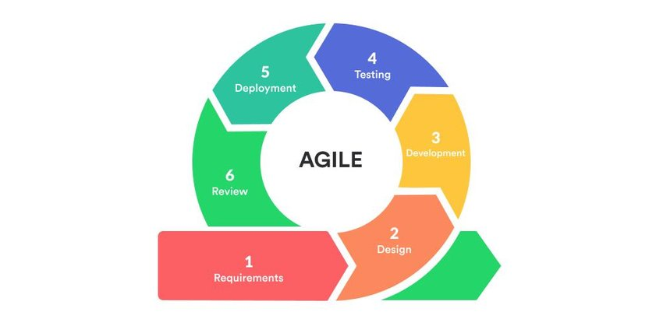Agile Methodology

Source: ResearchGate.net

**Phases of Agile Methodology**

Phase 1: Requirement Analysis. The gathering, compilation, and evaluation of information requirements is called requirement analysis.

The proponents created a Work Plan and a Gantt Chart to serve as a guide for the timeframe of each task throughout the development process. The proponents then selected repairers from Alaminos City, Pangasinan, to include in the system. Business name and location were recorded for later use.

A survey was prepared and conducted to determine the process of making job orders and problems that both repairer and client usually encounter. The proponents studied the data, developed flowcharts demonstrating procedures in a normal repair transaction, and established the system's required input and output. Implemented features in the application were also formulated in this phase, and the construction of user interfaces with the help of a use case diagram. An entity-relationship diagram was developed using Chen's notation for the database setup.

Reviews and brainstorming were made to improve and finalize the plan and better understand the system process.

Phase 2: Design. The conceptualization and construction of how the system will appear during the design phase.

In this stage, the proponents brainstormed, browsed the internet, and watched video tutorials to develop a layout of the system interface. A color scheme was chosen and integrated into the entire system.

A use case diagram was utilized for the formulation of the structural layout of the application. An initial prototype was developed using Adobe Photoshop and was used as a base design and was later improved.

Phase 3: Development and Coding. This phase entails implementing the software design using the programming language of choice.

With Android Studio, the programmer wrote the codes to build the app's structural architecture and functionalities with Java as the programming language. At first, the structural layout of the application was setup. This includes the basic pages and buttons in the application. Button functionalities were then integrated and the input functionalities of the application. Lastly, the programmer added the database queries to complete the Firebase Real-time Database process. This was the most time-consuming process in the entire SDLC. The phase continued until the desired result was achieved.

Phase 4: Testing. The testing phase is a process necessary to ensure the quality of a system.

At this point, the proponents listed and examined each application's functionality to see if they were working properly. Bugs and errors were listed and later fixed during this process. Its goal is to make sure that the code is error-free and that the program runs smoothly. In addition, the proponents installed the application on various devices to test whether it could be installed and run as expected.

Phase 5: Deployment. This stage entails the introduction and demonstration of the application to users. The proponents deployed the newly developed version of the application at this point to receive reviews from the end-user. End users evaluated the application, looked for bugs, and provided feedback. A User Acceptability test was prepared and conducted to assess the application's quality.

Phase 6: Review. In this phase, the application is monitored to ensure that everything runs smoothly.

The proponents continued to test every functionality of the system. Errors will be discovered and correctly addressed in this manner.

**Population and Locale of the Study**

Sarapsap was the original name of Alaminos City. The residents loved the city. It progressed and was later renamed in 1872 in honor of the Spanish Governor-General who came to visit. Alaminos was reclassified from a fourth to a third-class municipality in 1991 and then to a first-class municipality in 1903 with a gross income rise of 338.5 percent. Under former President Gloria Macapagal Arroyo, the municipality of Alaminos was transformed into a city on March 5, 2001.

There are roughly 29 electrical repair shops, and the majority of them are located in Barangay Poblacion, which serves as the commerce center. The Covid-19 outbreak affected the repair industry, forcing other repairers to close their businesses.

The proponents created questionnaires to collect data and information from repairers of Alaminos. Also, a survey was conducted among random end-users to gather data relevant to the system's client-side functionality. The respondents were mentioned in Table 2.

Table 2.

Respondents of the Study

|  |  |
| --- | --- |
| Respondents | Number of Respondents |
| Repairers | 8 |
| End-User | 200 |
| Total | 208 |

**Data Instrumentation**

Internet Research. The proponents used online resources like articles, books, and studies to gather relevant information. Also, the proponents watched video tutorials to gain more knowledge in programming and come up with a better design.

Survey Questionnaire. The proponents surveyed random individuals to determine the procedures they take to make job orders and the problems they usually encounter in finding repairers and creating transactions. The proponents used the gathered information to devise features to implement in the application and develop an efficient user interface for clients.

**Tools for Data Analysis**

Use Case Diagram. The proponents used a use case diagram to create a framework and design a user interface from the end-user's viewpoint.

Entity Relationship Diagram. The proponents used an Entity Relationship Diagram to fully comprehend the relationships between entities and understand the database's conceptual structure.

Weighted Mean. The following statistical tools and measures were used to analyze, describe, and interpret computation outcomes.

Formula $\overline{x}=\frac{\sum_{x}{w}}{n}$

Where

$\overline{x }$ = mean

x = number of respondents

w = weight

n = total number of respondents

Source: Amid, D.M. (2009) Fundamentals of STATISTICS

To compute the overall weighted mean, the proponents used the formula below.

$$OWM=\frac{\sum{awm}}{number of items}$$

Where

Awm = Average weighted mean per indicator

Number of items = the number of indicators per category

The scale of measurement. A statistical technique is used to acquire a wide perspective of the study's overall situation. The scaling system, which the proponents employed to monitor the respondents' perception of information, is included here. The results were determined using the scale in the table.

Table 3.

Scale of Measurement

|  |  |  |  |
| --- | --- | --- | --- |
| **Scale** | **Range** | **Interpretation** | **Descriptive**  **Interpretation** |
| 5 | 4.21-5.00 | Excellent | Condition is needed by missing. |
| 4 | 3.41-4.20 | Very Good | Condition is adequate, and functioning is fair. |
| 3 | 2.61-3.40 | Good | Condition is limited and functioning properly. |
| 2 | 1.81-2.60 | Fair | Condition is  functioning properly.  Condition is very extensive and functions very well. |
| 1 | 1.00-1.80 | Poor | Condition is needed by missing. |

**Tools for System Development**

Android Studio. It is the official Integrated Development Environment (IDE) for Android app development.

It uses XML for the structure and design and java programming language for the functionalities.

The proponents used Android Studio to write the codes for the entire application.

Adobe Photoshop. It is image-editing and manipulation software. It's also used to produce computer-generated graphic designs such as icons and logos.

The proponents used Photoshop to create the logo, icons, and buttons and the initial layout of the application.

Firebase. Firebase is a free online database that provides real-time web and mobile application updates. It also has its storage and uses multiple user authentication methods, such as phone, Facebook, and Google accounts. To create the app, the proponents employed Firebase as a database.

**Description of Initial Prototype**

This section will discuss and show the initial prototype of the proposed application RepairTech.

Figure 2.

Client’s Perspective

Base page

Repair Shop Information

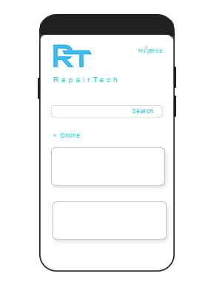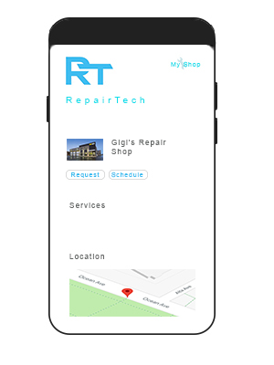

Repair shop is selected

The base page displays all repair providers near the user. When a clicked, the repairer’s details will be displayed on the repair shop page where location tracking,

request and scheduling functionality are present.

Figure 3.

Repair Provider’s Perspective

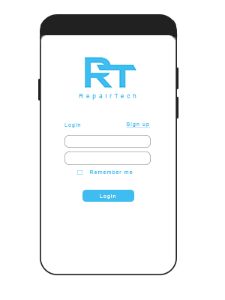

Login page

Base page



Repairer’s dashboard

Options

My shop is

selected

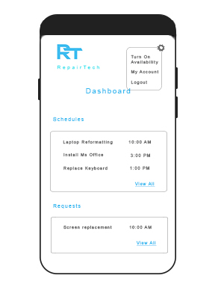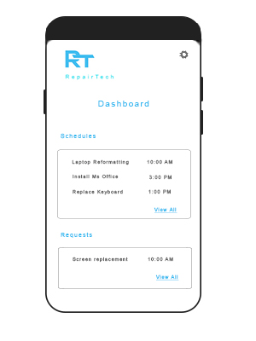

Upon clicking the My Shop button, the repairer will be prompted to log in where the correct username and password are required. After the login process, the repairer will be redirected to the repairer's dashboard, where the requests and set walk-in transactions are displayed.

Figure 4.

Registration form

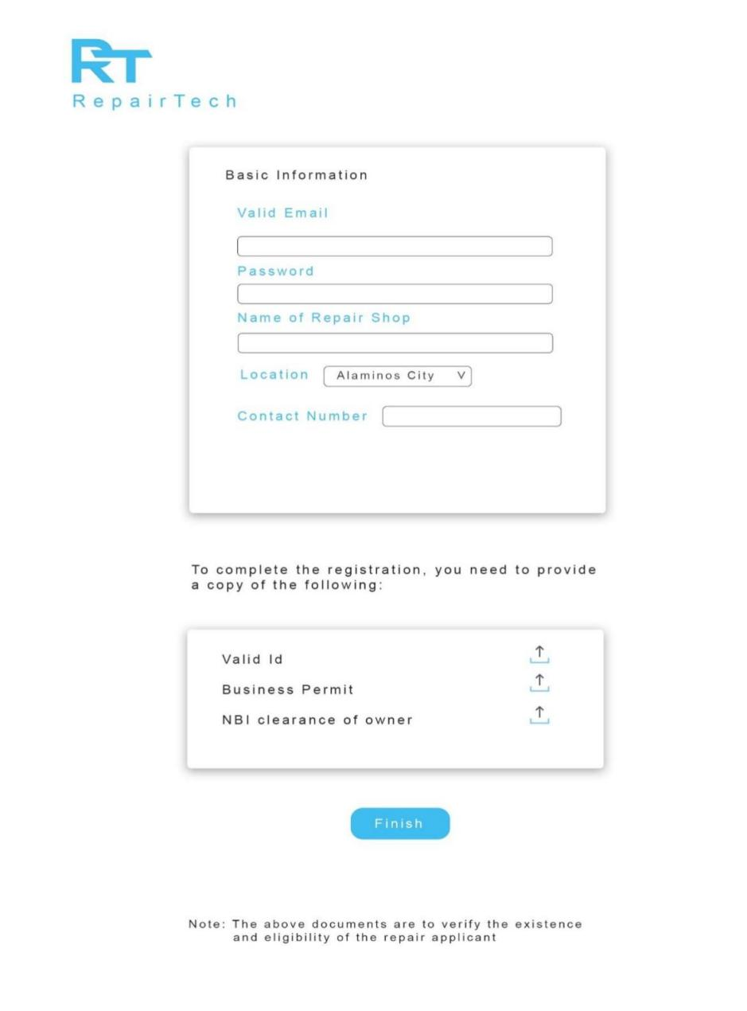

If a repairer wants to create an account, they must provide the necessary information on the registration page.

Figure 5.

Admin Dashboard

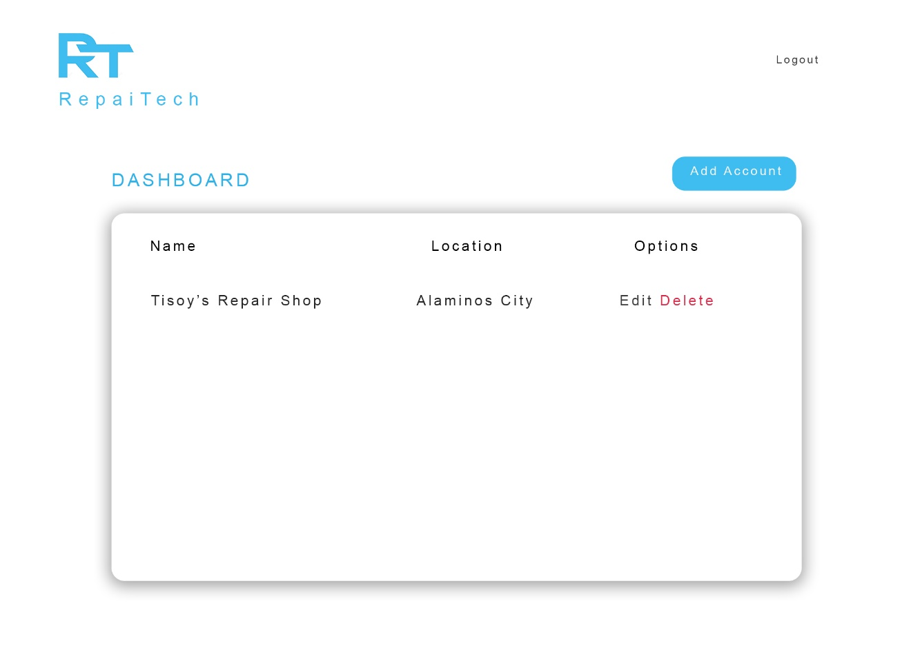

The administrator dashboard displays all pending registrations of repairers who want to create an account for the application. The administrator can manage these registrations through the administrator dashboard.

**The Proposed Implementation Plan**

Repair services providers from Alaminos City will be selected for the implementation. The application will be installed on their mobile phones and will be explained and demonstrated to them by the proponents to understand the application's functionalities thoroughly. For the client-side, randomly selected individuals will make use of the application. They will be instructed on how the application runs for the client-side.

These are the requirements for the implementation of the application.

* Internet Connection
* Minimum Android Version: 6 (Marshmallow)

Table 4.

Implementation Plan

|  |  |  |  |
| --- | --- | --- | --- |
| Strategy | Activities | Persons Involved | Duration |
| Installation and demonstration to repairers | Installation and demonstration of the application | * Proponents * Repair Service Providers | Two days |
| Installation and training of clients | Installation and training | * Proponents * Clients | Five days |

Chapter 3

**RESULTS AND DISCUSSION**

This chapter contains a discussion on the existing processes, difficulties encountered in the current system, features of the proposed system, and the acceptance of the proposed system in terms of functionality, reliability, usability, maintainability, and portability.

**Common Procedures in Accepting Job Orders and Releasing Items Repaired**

The proponents surveyed the repairers of Alaminos City and random end-users to gather data and identify the process of making and accepting job orders and releasing items.

Job Order Process. Typically, a job order begins with a client. The client then looks for a repairer in a certain manner. The repairer accepts or rejects the request and releases the item after the repair is completed based on his capabilities.

Figure 6.

Job Order Process

Start

Client

finds a repairer

Repairer

Accepts?

N

Y

Client waits?

N

Clients leaves the device?

Y

N

Y

Agreed date & time of the meeting

Repaired Device

End

According to the data gathered, 31.4 percent of respondents said they would wait for the repair to be completed. However, 18.8% say they will leave the item to be fixed, while 49.8% say it will depend on the nature of the repair.

Figure 7.

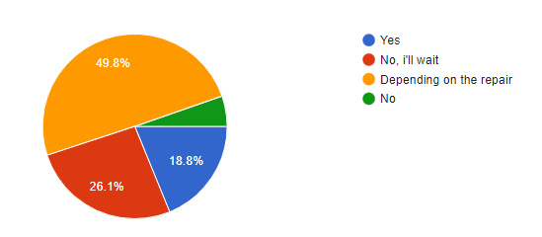Waiting/Leaving Items on Repairers

In a survey of repairers, most of them said that their clients leave their items.

Searching for Repair Service Provider. Fifty-six percent (56%) of end-users ask about available repairers in their locality, while 21.7 percent go out and find one themselves. Social media is used by 14% of people, while 8.2% of people use the internet to find information.

In a survey of repairers, most of their clients contact them via personal inquiry. Some use social media, and others use phone calls and text.

Figure 8.

Searching for Repair Service Provider

Start

Invoke method of searching:

1. Asking other people
2. Personal Inquiry
3. Social Media
4. Internet

Successful?

End

N

Y

Identifying and Choosing a Reliable Repairer. While there were various statements from the participants, the proponents narrowed down relevant responses to Quality, Trust, Price, Location, and Repairer Legitimacy. Furthermore, providing a warranty is an important component of being a dependable repairer. The outcome of the repair, the client's satisfaction, the time spent on the repair, past client feedback, and how other people talk about the repairer all contribute to quality. Trust is another factor they consider when selecting repairers based on the information acquired. The quantity of clients who patronize a particular repairer is a measure of trust. Some repairers demand much higher service prices than others. Thus, price is also a criterion for choosing a repairer, while some prefer the nearest available repairer. Furthermore, the legitimacy of the repair business is an important aspect of selecting a repairer based on the gathered data.

Figure 9.

Identifying and Choosing a Reliable Repairer

Apply Standards for selecting:

1. Quality
2. Trust
3. Price
4. Location
5. Legitimacy

Successful?

End

Start

N

Y

Contacting Repairers. To communicate with repairers, there are a variety of methods available. According to the collected data, 66.2 percent of end-users go to the store to contact their repairer, while 23.7 percent utilize phone and text messages. Furthermore, 9.7% use social media, whereas only 0.5% use email.

Figure 10.

Contacting Repairers

Start

Invoke method of contact:

1. Phone call or text message
2. Email
3. Personal Inquiry
4. Social Media

Successful?

End

N

Y

**Problems Encountered by the Electronic Shops and Its Clientele**

Based on the data gathered from the survey conducted to random end-users from Alaminos City, the following are the difficulties encountered:

Difficulty in Finding a Repair Provider. A problematic aspect of hiring a repairer is assessing whether or not they are reliable and capable of completing the work. Another issue is establishing whether or not a repairer is available. Additionally, finding repairer stalls can be tough, particularly if you are not a local and are unfamiliar with the area.

Difficulty in Knowing the Status of Service Repair Request. Another issue with item release is the difficulty of knowing whether the repair has been completed. This causes the client to return to the repairer multiple times to check for their item, wasting both time and resources. Repairers replacing components of their equipment with older or broken ones is also an issue. According to the respondents, some repairers overcharge for services, especially if you are not from the area.

Based on the data from the survey conducted to repairers from Alaminos City, the following are the difficulties encountered.

Unanticipated repair requirements. According to the data acquired, repairers often lack the necessary parts or equipment to perform the repair. This leads to repairers declining the request or a prolonged repair timeframe.

Unorganized Repair Records. Although it is not a massive concern, repairers employ the conventional pen and paper method of detailing ongoing repair, which is less organized and secure than digital records and poses the risk of lost or destroyed lists.

**Features Incorporated in the Mobile Application**

The development of Repairtech is to provide the following features.

Online searching for the repairer. The application's main interface allows potential clients to look for nearby repairers. Users may now easily search for repair shops online by searching for a repairer.

Figure 11.

Online searching for the repairer.

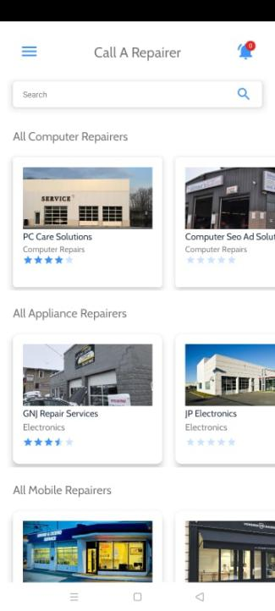

Walk-in Schedule. The app allows users to select a service from a repairer of their choosing and then set a schedule for when they will visit the repairer in person. The user provides information on the repair and the walk-in time. Figure 12 shows the schedule functionality.

Figure 12.

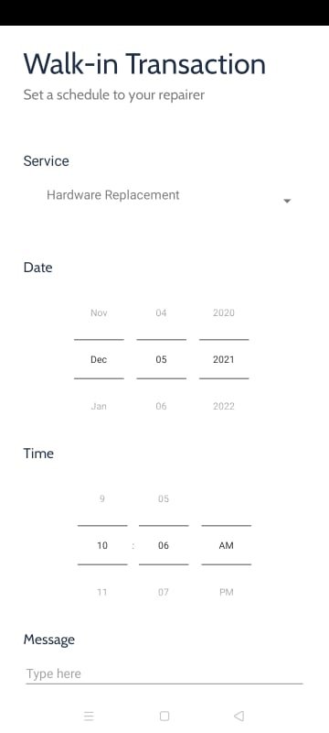Walk-in Schedule

Home Service Request. The software allows users to select a service from a repairer of their choosing and then request a home service, in which they can define the location of the repair. Figure 9 shows the requested functionality.

Figure 13.

Home Service Request

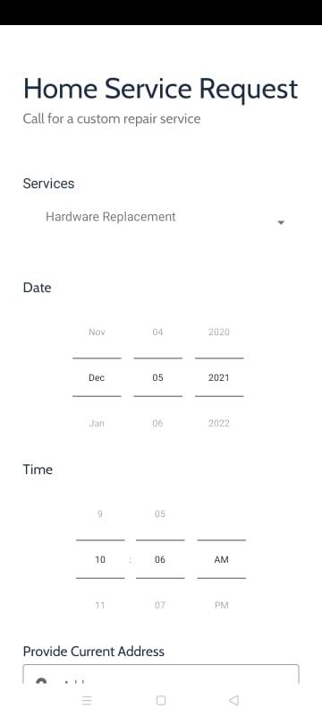

Location Tracking Using Google Maps. The software allows users to select a service from a repairer of their choosing and then request a home service, in which they can define the location of the repair. Figure 9 shows the requested functionality.

Figure 14.

Location Tracking Using Google Maps

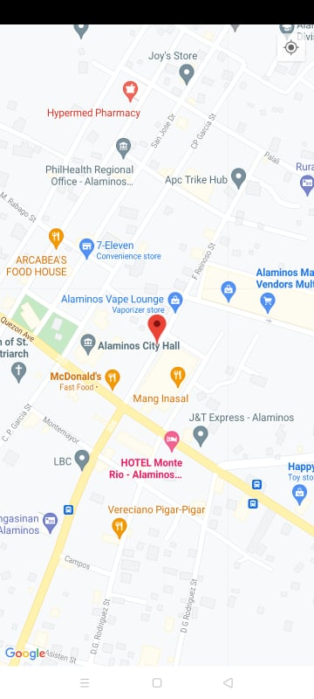

Notification for Clients. Notifications are implemented in the application. If a request is refused or accepted, the user will be alerted. Also, if a repair transaction where the client left the item for repair, a notification will be sent to the client upon completion.

Figure 15.

Notification for Clients

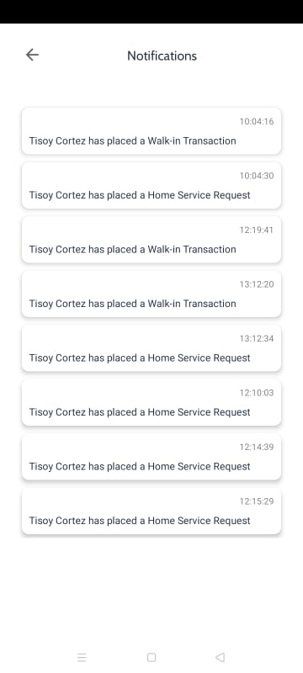

List. The application allows repairs to see all requests and schedules placed by clients—figure 11 shows listing functionality.

Figure 16.

List

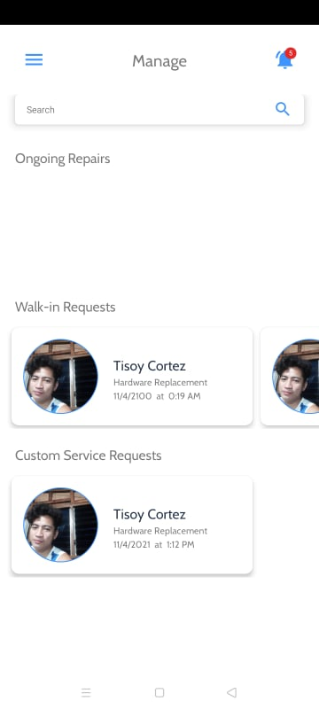

They have the option of accepting or declining the request. They can label the continuing repairs as completed. When an ongoing repair is designated as complete, the client will be notified that their item has been repaired and is ready for pickup. Figure 12 shows accept or decline functionality.

Notification for Repairers. The application implements notification functionality. The repairer will be notified if a request is received. Figure 13 shows the notification functionality.

Figure 17.

Notification for Repairers



**Acceptability level of the developed system**

In the completion of Repairtech, the system was assessed by repairers registered in the application and end-users.

Functionality. Table 5 shows the perception of repairers as evaluators of the application's functionality. In accordance with suitability, which pertains to the appropriateness of the functions implemented, the application garnered a mean of 4.71 percent. This means that the functionalities fit the goal of the application. In terms of accuracy, the application garnered 4.86 percent. This states that the data output of the application is accurate and thus reliable. For security, the application garnered a mean of 4.71 which states that the application imposes security features that prevent unauthorized access. The overall weighted mean of the application is 4.76, marked as excellent.

Table 5.

System Evaluation According to Functionality

|  |  |  |
| --- | --- | --- |
| FUNCTIONALITY | Mean | Description |
| 1. Suitability – The functions of the system are appropriate. | 4.71 | EXCELLENT |
| 2. Accuracy – The system’s results are accurate. | 4.86 | EXCELLENT |
| 3. Security – It prevents unauthorized access. | 4.71 | EXCELLENT |
| Weighted Mean | 4.76 | EXCELLENT |

Reliability. Table 6 shows the perception of repairers as evaluators of the application's reliability. According to maturity, which states the minimal frequency of software faults and failures, the application garnered 4.86 percent. This means that errors in the application are at the very least. The application garnered a mean of 4.86 percent in terms of fault tolerance. This states that the application is capable of handling errors. For recoverability, the application garnered a mean of 4.71, which says that it can easily recover its performance in case of error. The overall weighted mean of the application is 4.81, marked as excellent.

Table 6.

System Evaluation According to Reliability

|  |  |  |
| --- | --- | --- |
| RELIABILITY | Mean | Description |
| 1. Maturity – There is a minimum frequency of software faults/failures. | 4.86 | EXCELLENT |
| 2. Fault Tolerance – The system can handle system errors. | 4.86 | EXCELLENT |
| 3. Recoverability – System’s performance is re-establishing from failure. | 4.71 | EXCELLENT |
| Weighted Mean | 4.81 | EXCELLENT |

Usability. Table 7 shows the perception of repairers as evaluators of the application's usability. According to understandability, which states that the concepts incorporated in the application are easy to recognize, the application garnered 4.86 percent. This means that the words, icons, and buttons added to the application are easy to understand. In terms of learnability, the application garnered a mean of 5 percent. This states that the processes occurring in the application are easy to understand. For operability, the application garnered a mean of 4.86 which states that the controls and different interfaces are easy to navigate. The overall weighted mean of the application is 4.9, marked as excellent.

Table 7.

System Evaluation According to Usability

|  |  |  |
| --- | --- | --- |
| USABILITY | Mean | Description |
| 1. Understandability – Concepts are easily recognized. | 4.86 | EXCELLENT |
| 2. Learnability – The system’s functions are easy to learn | 5 | EXCELLENT |
| 3. Operability – The system is easy to use or operate. | 4.86 | EXCELLENT |
| Weighted Mean | 4.9 | EXCELLENT |

Efficiency. Table 8 shows the perception of repairers as evaluators of the application's efficiency. According to its time behavior, which states that there is a fast response time, the application garnered 4 percent. This means a relatively fast response time in the application's performance. The application garnered a mean of 4.20 percent in terms of resource behavior. This states that the data inputs for the application are easy to provide. The overall weighted mean of the application is 4.1, marked as very good.

Table 8.

System Evaluation According to Efficiency

|  |  |  |
| --- | --- | --- |
| EFFICIENCY | Mean | Description |
| 1. Time Behavior – There is a fast response time in the system. | 4 | Very Good |
| 2. Resource Behavior – Resources used for system performance are accessible. | 4.20 | Very Good |
| Weighted Mean | 4.1 | Very Good |

Maintainability. Table 9 shows the perception of repairers as evaluators of the application's maintainability. According to its analyzability, which states that failures can be easily identified, the application garnered 4.38 percent. This means that the application does an excellent job of informing the user about the errors in the processes done in the application. In terms of stability, the application garnered a mean of 4.03 percent. This states that the components inside the application are easy to modify. The overall weighted mean of the application is 4.20, marked as very good.

Table 9.

System Evaluation According to Maintainability

|  |  |  |
| --- | --- | --- |
| MAINTAINABILITY | Mean | Description |
| 1. Analyzability – Failure causes can easily be identified | 4.38 | EXCELLENT |
| 2. Stability – Components can be easily modified | 4.03 | Very good |
| Weighted Mean | 4.20 | Very good |

Portability. Table 10 shows the perception of repairers as evaluators of the application's portability. According to its adaptability, which states that specification changes are done easily, the application garnered 4 percent. This means that the application has minimal issues regarding the specifications of different mobile devices. The overall weighted mean of the application is 4, marked as very good.

Table 10.

System Evaluation According to Portability

|  |  |  |
| --- | --- | --- |
| PORTABILITY | Mean | Description |
| 1. Adaptability – Specification changes are done easily. | 4 | Very Good |
| Weighted Mean | 4 | Very Good |

Functionality. Table 11 shows clients' perceptions as evaluators of the application's functionality. In accordance with suitability, which pertains to the appropriateness of the functions implemented, the application garnered a mean of 4.78 percent. This means that the functionalities fit the goal of the application. In terms of accuracy, the application garnered 4.89 percent. This states that the data output of the application is accurate and thus reliable. For security, the application garnered a mean of 4.78 which states that the application imposes security features that prevent unauthorized access. The overall weighted mean of the application is 4.71, marked as excellent.

Table 11.

System Evaluation According to Functionality

|  |  |  |
| --- | --- | --- |
| FUNCTIONALITY | Mean | Description |
| 1. Suitability – The functions of the system are appropriate. | 4.78 | EXCELLENT |
| 2. Accuracy – The system’s results are accurate. | 4.89 | EXCELLENT |
| 3. Security – It prevents unauthorized access. | 4.78 | EXCELLENT |
| Weighted Mean | 4.81 | EXCELLENT |

Reliability. Table 12 shows clients' perceptions as evaluators of the application's reliability. According to maturity, which states the minimal frequency of software faults and failures, the application garnered 3.98 percent. This means that errors in the application are at the very least. The application garnered a mean of 4.28 percent in terms of fault tolerance. This states that the application is capable of handling errors. For recoverability, the application garnered a mean of 4.56, which says that it can easily recover its performance in case of error. The overall weighted mean of the application is 4.27, marked as excellent.

Table 12.

System Evaluation According to Reliability

|  |  |  |
| --- | --- | --- |
| RELIABILITY | Mean | Description |
| 1. Maturity – There is a minimum frequency of software faults/failures. | 3.98 | Very good |
| 2. Fault Tolerance – The system can handle system errors. | 4.28 | EXCELLENT |
| 3. Recoverability – System’s performance is re-establishing from failure. | 4.56 | EXCELLENT |
| Weighted Mean | 4.27 | EXCELLENT |

Usability. Table 13 shows clients' perceptions as evaluators of the application's usability. According to understandability, which states that the concepts incorporated in the application are easy to recognize, the application garnered a 4.67 percent. This means that the words, icons, and buttons added to the application are easy to understand. In terms of learnability, the application garnered a mean of 4.89 percent. This states that the processes occurring in the application are easy to understand. For operability, the application garnered a mean of 4.78 which states that the controls and different interfaces are easy to navigate. The overall weighted mean of the application is 4.78, marked as excellent.

Table 13.

System Evaluation According to Usability

|  |  |  |
| --- | --- | --- |
| USABILITY | Mean | Description |
| 1. Understandability – Concepts are easily recognized. | 4.67 | EXCELLENT |
| 2. Learnability – The system’s functions are easy to learn | 4.89 | EXCELLENT |
| 3. Operability – The system is easy to use or operate. | 4.78 | EXCELLENT |
| Weighted Mean | 4.78 | EXCELLENT |

Efficiency. Table 14 shows clients' perceptions as evaluators of the application's efficiency. According to its time behavior, which states a fast response time, the application garnered a mean of 3.63 percent. This means a relatively fast response time in the application's performance. The application garnered a mean of 4.26 percent in terms of resource behavior. This states that the data inputs for the application are easy to provide. The overall weighted mean of the application is 3.94, marked as very good.

Table 14.

System Evaluation According to Efficiency

|  |  |  |
| --- | --- | --- |
| EFFICIENCY | Mean | Description |
| 1. Time Behavior – There is a fast response time in the system. | 3.63 | Very good |
| 2. Resource Behavior – Resources used for system performance are accessible. | 4.26 | EXCELLENT |
| Weighted Mean | 3.94 | Very good |

Maintainability. Table 15 shows clients' perceptions as evaluators of the application's maintainability. According to its analyzability, which states that failures can be easily identified, the application garnered 4.56 percent. This means that the application does an excellent job of informing the user about the errors in the processes done in the application. In terms of stability, the application garnered a mean of 4.78 percent. This states that the components inside the application are easy to modify. The overall weighted mean of the application is 4.67, marked as excellent.

Table 15.

System Evaluation According to Maintainability

|  |  |  |
| --- | --- | --- |
| MAINTAINABILITY | Mean | Description |
| 1. Analyzability – Failure causes can easily be identified | 4.56 | EXCELLENT |
| 2. Stability – Components can be easily modified | 4.78 | EXCELLENT |
| Weighted Mean | 4.67 | EXCELLENT |

Portability. Table 16 shows clients' perceptions as evaluators of the application's portability. According to its adaptability, which states that specification changes are done easily, the application garnered a mean of 4.25 percent. This means that the application has minimal issues regarding the specifications of different mobile devices. The overall weighted mean of the application is 4.25, marked as excellent.

Table 16.

System Evaluation According to Portability

|  |  |  |
| --- | --- | --- |
| MAINTAINABILITY | Mean | Description |
| 1. Adaptability – Specification changes are done easily. | 4.25 | EXCELLENT |
| Weighted Mean | 4.25 | EXCELLENT |

Table 17 and 18 shows the overall weighted mean of the acceptability survey.

Table 17.

Overall Weighted Mean for Repairers

|  |  |  |
| --- | --- | --- |
| Area | Average Weighted Mean | Descriptive Interpretation |
| 1. Functionality | 4.76 | Excellent |
| 1. Reliability | 4.81 | Excellent |
| 1. Usability | 4.9 | Excellent |
| 1. Efficiency | 4.1 | Very Good |
| 1. Maintainability | 4.20 | Very Good |
| 1. Portability | 4 | Very Good |
| Overall | 4.46 | Excellent |

Table 18. Overall Weighted Mean for Clients

|  |  |  |
| --- | --- | --- |
| Area | Average Weighted Mean | Descriptive Interpretation |
| 1. Functionality | 4.81 | Excellent |
| 1. Reliability | 4.27 | Excellent |
| 1. Usability | 4.78 | Excellent |
| 1. Efficiency | 3.94 | Very Good |
| 1. Maintainability | 4.67 | Excellent |
| 1. Portability | 4.25 | Excellent |
| Overall | 4.45 | Excellent |

With the computed OWM for repairer acceptability test of 4.46 and client acceptability test of 4.45 both interpreted as excellent, the application is ready for deployment.

Chapter 4

**SUMMARY, CONCLUSIONS, AND RECOMMENDATIONS**

This chapter summarizes the study's findings and the conclusions to the problems concerned with developing the proposed mobile application and provides recommendations on its proper implementations and further developments.

**Summary**

This research aims to design and develop an Android mobile application that will serve as a forum for repair service providers and clients to connect.

Furthermore, this study aims to achieve the following:

1. identify common procedures in accepting job orders and releasing items repaired;
2. identify problems encountered by the electronic shops and their clientele;
3. devise features to be incorporated in the proposed mobile application; and
4. determine the acceptability level of the developed system: (a)functionality, (b)reliability, (c)usability, (d)efficiency, (e)maintainability, (f)portability.

This project study utilized Android Studio as the IDE and Java as the programming language to implement the different features of the proposed system using the Agile Development Model. The Agile Model has the following phases:

a. Planning

b. Design

c. Coding

d. Testing

e. Deployment

f. Review

**Findings**

1. The standard procedures in accepting job orders and releasing items repaired are: searching for a repair provider, identifying and choosing a reliable repairer, and contacting the repairer;

2. The problems encountered by the electronic repair shops are: unanticipated repair requirements and unorganized repair records. The problems clients face are finding a repairer and difficulty in knowing the status of the service repair request. Other issues in transactions such as repairers replacing components of their equipment with broken ones and repairers overcharging for services;

3. The features implemented for repairers are Listing and notification. The features that are implemented for clients are: Online searching of repairer, walk-in scheduling, requesting of home service requests, location tracking using Google maps and notification; and

4. Based on the survey conducted by the proponents, the weighted mean in terms of Functionality, Reliability, Usability, Efficiency, Maintainability, and Portability for both repairers and clients is Excellent.

**Conclusions**

Based on the findings, the following conclusions are drawn:

1. The current process for a normal repair transaction, starting from finding a repairer to the releasing of items after the repair, specifically repairer-client communication, poses a lot of inconveniences, especially to clients;

2. There is a limited way of knowing the location of repairers. The same goes for contacting them and determining whether or not they are available. Clients tend to leave their devices to the repairer, but there is a limited way of notifying the client when the repair is finished. Repairers often lack the necessary parts needed to perform the repair. Repairtech does a great job in addressing these issues, for it is designed to make communication between repairers and clients easier;

3. The proposed system features are online searching of the nearest available repairer, location tracking of the repairer, setting walk-in transactions, home service request functionality, and notification. This system would be helpful to people who are in need of repair services. They will be provided with instant information about where the repair stall is. Also, whenever they leave their device for repair, they will be notified if the job is already done. It also benefits repairers, for they will be provided a digital list of their ongoing repairs. They can also use the system's scheduling functionality to prepare the equipment and parts required. Accepting requests for home services is also provided; and

4. The application garnered an assessment grade of Excellent. Repair companies interested in using the app can implement it in their organization. Entrepreneurs can also use the app to build a business by monetizing it via downloads, memberships, advertisements, and other methods. The Alaminos Local Government Unit can also utilize the app to strengthen the electronic repair community and increase productivity.

**Recommendations**

The following were the recommendations for the implementation and further development of the system:

1. Focusing on lower versions of Android is recommended. The system may also be configured to run on iOS;
2. it is recommended not to be indoors while using the app so that the GPS functionality will work more efficiently; and

To effectively execute the application, it must be properly maintained to avoid viruses that lead to data loss and the application's effective operation.

**REFERENCES**

Yaadav, R. (2018). Refurbished Electronic Gadgets and Repair Service Industry. Retrieved April 17, 2021, from <https://www.linkedin.com/pulse/refurbished-> electronic-gadgets-repair-service-industry

Caruso, A. (2020). As More People Rely On Technology During Coronavirus Crisis, Tech Repair Shops Remain Open, Retreived April 18, 2021, from [https://www.wfyi.org/news/articles/as-more-people- rely-on-technology-during-coronavirus-crisis-tech- repair-shopsremain-open](https://www.wfyi.org/news/articles/as-more-people-rely-on-technology-during-coronavirus-crisis-tech-repair-shops-remain-open)

Ahmed, S. I. (2019–2020). Repairing and Recycling of Digital Electronics during COVID-19, Retrieved April 20, 2021, from[https://www.iie.org/en/Programs/IIE- Centennial-Fellowship/Centennial-Fellows-Blogs/2019- Blog/SyedIshtiaque-Ahmed](https://www.iie.org/en/Programs/IIE-Centennial-Fellowship/Centennial-Fellows-Blogs/2019-Blog/Syed-Ishtiaque-Ahmed)

The World Bank (2020). Harnessing Digital Technologies Can Help Philippines Overcome Impact of Pandemic, Hasten Recovery. Retrieved April 15, 2021, from <https://www.worldbank.org/en/news/press-> release/2020/10/05/harnessing-digital-technologies- canhelp-philippines-overcome-impact-of-pandemic- hasten-recovery.

Dillera, A. (2020), Philippine Government Services Going Fully Digital by 2022, Retrieved on April 20, 2021, from <https://opengovasia.com/philippine-government-> services-going-fully-digital-by-2022

Elluminati inc. (2021, March 10). Uber For iPhone Repair, A Mobile and Gadget Repairing App Platform*.* Retreived April 14, 2021 from [https://www.elluminatiinc.com/mobile-repair-mobile- application/](https://www.elluminatiinc.com/mobile-repair-mobile-application/)

Canoza, A. (2020). COVID-19’s impact on MSMEs: What to brace for and how to cope. Retrieved April 14, 2021,from [https://www.bworldonline.com/covid-19s-impact-on- msmes-what-to-brace-for-and-how-to-cope/](https://www.bworldonline.com/covid-19s-impact-on-msmes-what-to-brace-for-and-how-to-cope/)

Lavilla, D. S. (2020, August 10). Innovation and digital transformation: How are Philippine MSMEs performing? Retrieved April 15, 2021, from [https://www.pwc.com/ph/en/business-unusual/innovation- and-digital-transformation-how-are-philippine-msmes- performing.html](https://www.pwc.com/ph/en/business-unusual/innovation-and-digital-transformation-how-are-philippine-msmes-performing.html)

Saliola, F., & Islam, A. (2020, September 24). How to Harness the Digital Transformation of the Covid Era. Retrieved April 16, 2021, from [https://hbr.org/2020/09/how-to-harness-the-digital- transformation-of-the-covid-era](https://hbr.org/2020/09/how-to-harness-the-digital-transformation-of-the-covid-era)

**Appendices**

Appendix A

**Gantt Chart**

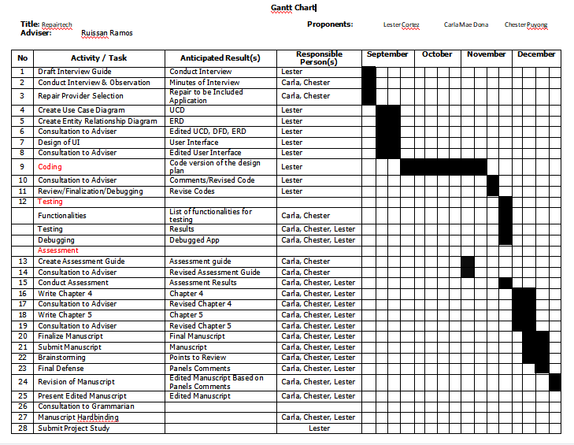

Appendix B

**Work Plan**

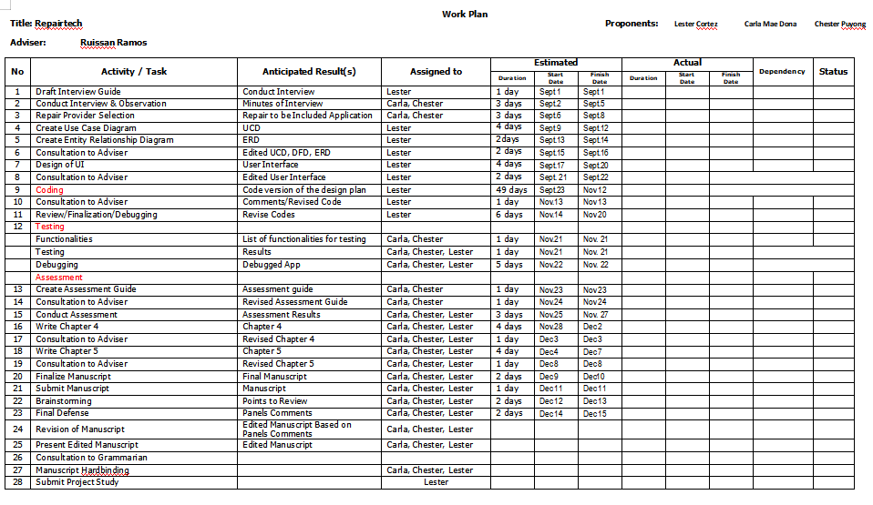

Appendix C

**Letter to Conduct Studies**

Dear Ma’am/Sir,

Warmest Greetings!

In partial fulfillment of our requirements in Capstone Project 1, we third year students of BS in Information Technology of Pangasinan State University – Alaminos City Campus would like to ask your good office to allow us to conduct our study entitled “RepairTech: An Android Mobile Application for Repair Providers”.

With your permission, the members of the group: Carla Mae Dona, Lester Cortez and Chester John Puyong plans to conduct interviews, observations, request sample documents, and float survey questionnaires to stakeholders. Rest assured that data gathered will remain confidential and will be used solely for the purpose of this project.

We believe that you are with us in our enthusiasm to finish and execute this project, an opportunity for greater learning and leveraging our skills. We hope of your positive response on this humble matter. Your approval will be greatly appreciated.

Respectfully yours,

**LESTER C. CORTEZ**

*Project Leader*

Noted by:

**MR. RUISSAN A. RAMOS**

*Project Adviser*

Appendix D

**Initial Interview Guide**

* 1. Interview Guide for Repair Providers

Name of Repairer/Repair Shop:

Working hours before Covid-19:

Working hours during Covid-19:

Average No. of customers before Covid-19:

Average No. of customers during Covid-19:

How is the business doing during Covid-19?

What are the issues you encountered during Covid-19?

What steps are you taking to address these issues?

* 1. Interview Guide for Users

1. Is it tough to find a repair service provider during current crisis?

2. What is your method of seeking repair shops?

Appendix E

**Survey Guide for Repairers**

Repair shop name :

Repair Type (Computer/Mobile/Appliances/others) :

**Procedures in Accepting Job Orders and Interacting with Customers**

1. How do customers request service from your repair shop?
2. Do clients wait for the device to be repaired?
3. Do you keep a list of all your ongoing repairs?
4. Do you cater home service request?
5. How do clients contact you?
6. Do you offer warranty on your repair services?

**Problems Encountered by Repairer**

1. What are the common problems that you encounter in your shop’s daily transaction?
2. What problems do you encounter in keeping track of the agreed time frame of repair?

Appendix F

**Survey Guide for End-users**

Survey Guide for Repair Shop Clients

**Procedures in Making Job Orders and Releasing of Items**

How do you find repair shops in your area?

1. Do you take your device to a repair shop and leave it there? Or will you wait for the repair to be completed?
2. Do you usually request for a home service?
3. How do you contact your repairer?
4. What are your criteria in choosing a repair shop?
5. How do you identify a reliable repair shop?

**Problems Encountered by Clients**

1. What problems do you encounter in finding a repair provider?
2. What problems do you encounter when transacting to repair shops?

Appendix G

**Use Case Diagram**



Repairer

User

Accept/Decline Request

Logout

See Repairers

Login

Add Rating

Send Request

See Requests

Add Comment

Appendix H

**Use Case Description**

**For Client**

|  |  |  |
| --- | --- | --- |
| Use Case | Login | |
| Description | This is use to illustrate Login in the system | |
| Actor | | System |
| Normal Flow | | |
| 2. Encode phone number and Password  3. click Login button | | 1. Display Login Page  4. Display Dashboard |
| Except Flow(Encounter error in password or phone number) | | |
| 3. click Login button  5. Enter the correct password or username  6. click Login button | | 4. Display error message for the password or username  7. Display Dashboard |

|  |  |  |
| --- | --- | --- |
| Use Case | See Repairers | |
| Description | This is use to illustrate display of repairers in the system | |
| Actor | | System |
| Normal Flow | | |
| 2. Selects one repairer of choice | | 1. Display Repairers  3. Display repairer details |

|  |  |  |
| --- | --- | --- |
| Use Case | Add Comment | |
| Description | This is use to illustrate Add Comment functionality in the system | |
| Actor | | System |
| Normal Flow | | |
| 2. Navigates to comment interface  3. Enters Comment  4. Taps add comment button | | 1. Display repairer details  5. Saves added comment to database |
| Except Flow(Encounter error in comment) | | |
| 1. Taps add comment button 2. Provides required data | | 5. Display error message for the comment if field is empty   1. Saves comment to database |

|  |  |  |
| --- | --- | --- |
| Use Case | Add Rating | |
| Description | This is use to illustrate Add Rating functionality in the system | |
| Actor | | System |
| Normal Flow | | |
| 2. Navigates to ratings interface  3. Enters Rating  4. Taps submit button | | 1. Display repairer details  5. Saves rating to database |

|  |  |  |
| --- | --- | --- |
| Use Case | Send Request | |
| Description | This is use to illustrate Request functionality in the system | |
| Actor | | System |
| Normal Flow | | |
| 2. Taps sched/request button  3. Enters required fields  4. Taps Submit button | | 1. Display repairer details   1. Saves request to database 2. Sends notification to the repairer |
| Except Flow(Encounter error in password or username) | | |
| 4. Taps Submit button   1. Provides required data | | 1. Display error message if fields are empty 2. Saves request to database |

**For Repairer**

|  |  |  |
| --- | --- | --- |
| Use Case | Login | |
| Description | This is use to illustrate Login in the system | |
| Actor | | System |
| Normal Flow | | |
| 2. Encode phone number and Password  3. click Login button | | 1. Display Login Page  4. Display Dashboard |
| Except Flow(Encounter error in password or username) | | |
| 3. click Login button  5. Enters the correct password or username  6. click Login button | | 4. Display error message for the password or username  7. Display Dashboard |

|  |  |  |
| --- | --- | --- |
| Use Case | See Request | |
| Description | This is use to illustrate Request List in the system | |
| Actor | | System |
| Normal Flow | | |
| 1. Taps request of choice | | 1. Display repairer dashboard   1. Displays request details |

|  |  |  |
| --- | --- | --- |
| Use Case | Accept/Decline Request | |
| Description | This is use to illustrate Accepting or Declining requests in the system | |
| Actor | | System |
| Normal Flow | | |
| 1. Taps Accept/Decine button | | 1. Display request details   1. Updates database 2. Sends notification to client |

Appendix I

**Entity Relationship Diagram**

(Chen’s Notation)

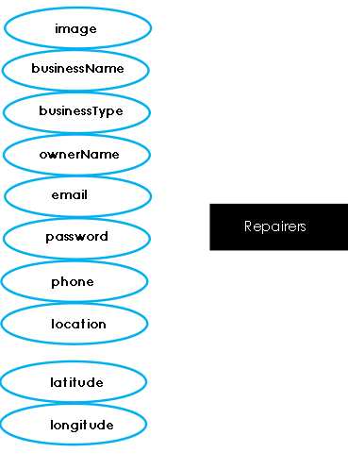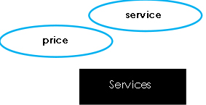

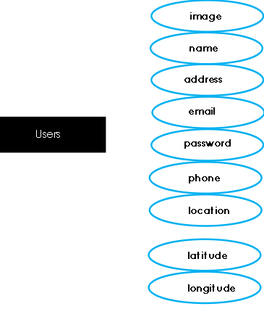

has

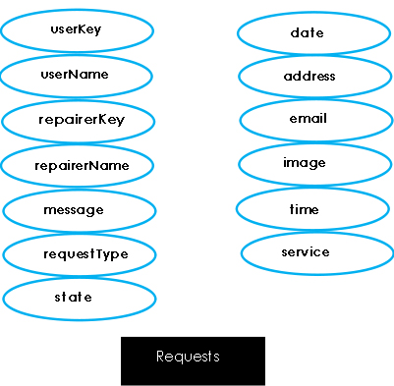

sendsend

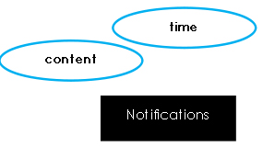

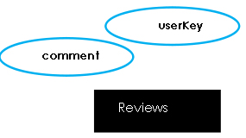

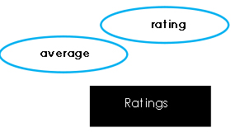

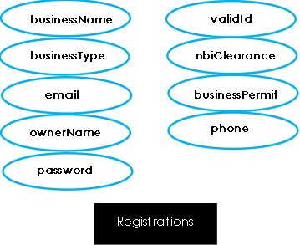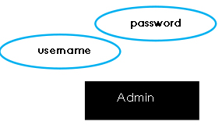

has

Appendix J

**Acceptability Questionnaire**

ACCEPTABILITY OF REPAIRTECH

(adapted from ISO 9126-1 by McCall (1997))

Date: _____________________

Name of Respondent (optional): _______________________

Sex: __ Male __ Female

Office: _______

Position/Designation:___________

Direction: Please evaluate/rate the following items to determine the acceptability of the by checking the corresponding box using the scale below:

5 – Excellent 4 – Very Good 3 – Good

2 – Fair 1 – Poor

|  |  |  |  |  |  |  |
| --- | --- | --- | --- | --- | --- | --- |
| **Functionality** | | 5 | 4 | 3 | 2 | 1 |
| 1 | Suitability – The functions of the system are appropriate. |  |  |  |  |  |
| 2 | Accuracy – The system’s results are accurate. |  |  |  |  |  |
| 4 | Security – It prevents unauthorized access. |  |  |  |  |  |
| **Reliability** | |  |  |  |  |  |
| 1 | Maturity – There is minimal frequency of software faults/failures. |  |  |  |  |  |
| 2 | Fault Tolerance – The system has capability of handling system errors. |  |  |  |  |  |
| 3 | Recoverability – System’s performance is re-establishing from failure. |  |  |  |  |  |
| **Usability** | |  |  |  |  |  |
| 1 | Understandability – Concepts are easily recognized. |  |  |  |  |  |
| 2 | Learnability – The system’s functions are easy to learn |  |  |  |  |  |
| 3 | Operability – The system is easy to use or operate. |  |  |  |  |  |
| **Efficiency** | |  |  |  |  |  |
| 1 | Time Behavior – There is fast response time of the system. |  |  |  |  |  |
| 2 | Resource Behavior – Resources used for system performance are accessible. |  |  |  |  |  |
| **Maintainability** | |  |  |  |  |  |
| 1 | Analyzability – Failure causes can easily be identified |  |  |  |  |  |
| 2 | Stability – Components can be easily modified |  |  |  |  |  |
| **Portability** | |  |  |  |  |  |
| 1 | Adaptability – Specification changes are done easily. |  |  |  |  |  |

Comments:

_______________________________________________________________________________________________________________________________________________________________________________________________________________________________________________________________

This is the end of the survey questionnaire. Thank you very much for your time and generous cooperation.

_______________________

Respondent’s Signature

Appendix K

**Tabulation of Result**

**Repairer**

|  |  |  |
| --- | --- | --- |
| **Functionality** | **Mean** | **Description** |
| 1. Suitability – The functions of the system are appropriate | 4.71 | EXCELLENT |
| 2. Accuracy – The system’s results are accurate. | 4.86 | EXCELLENT |
| 3. Security – It prevents unauthorized access. | 4.71 | EXCELLENT |
| **Reliability** |  |  |
| 1. Maturity – There is minimal frequency of software faults/failures. | 4.86 | EXCELLENT |
| 2. Fault Tolerance – The system has capability of handling system errors.. | 4.86 | EXCELLENT |
| 3. Recoverability – System’s performance is re-establishing from failure. | 4.71 | EXCELLENT |
| **Usability** |  |  |
| 1. Understandability – Concepts are easily recognized. | 4.86 | EXCELLENT |
| 2. Learnability – The system’s functions are easy to learn | 5 | EXCELLENT |
| 3. Operability – The system is easy to use or operate. | 4.86 | EXCELLENT |
| **Efficiency** |  |  |
| 1. Time Behavior – There is fast response time of the system. | 4 | VERY GOOD |
| 2. Resource Behavior – Resources used for system performance are accessible. | 4.20 | VERY GOOD |
| **Maintenance** |  |  |
| 1. Analyzability – Failure causes can easily be identified | 4.38 | EXCELLENT |
| 2. Stability – Components can be easily modified | 4.03 | VERY GOOD |
| **Portability** |  |  |
| 1. Adaptability – Specification changes are done easily. | 4 | VERY GOOD |

**Client**

|  |  |  |
| --- | --- | --- |
| **Functionality** | **Mean** | **Description** |
| 1. Suitability – The functions of the system are appropriate | 4.78 | EXCELLENT |
| 2. Accuracy – The system’s results are accurate. | 4.89 | EXCELLENT |
| 3. Security – It prevents unauthorized access. | 4.78 | EXCELLENT |
| **Reliability** |  |  |
| 1. Maturity – There is minimal frequency of software   faults/failures. | 3.98 | VERY GOOD |
| 2. Fault Tolerance – The system has capability of handling system errors. | 4.28 | EXCELLENT |
| 3. Recoverability – System’s performance is re-establishing from failure. | 4.56 | EXCELLENT |
| **Usability** |  |  |
| 1. Understandability – Concepts are easily recognized. | 4.67 | EXCELLENT |
| 2. Learnability – The system’s functions are easy to learn | 4.89 | EXCELLENT |
| 3. Operability – The system is easy to use or operate. | 4.78 | EXCELLENT |
| **Efficiency** |  |  |
| 1. Time Behavior – There is fast response time of the system. | 3.63 | VERY GOOD |
| 2. Resource Behavior – Resources used for system performance are accessible. | 4.26 | EXCELLENT |
| **Maintainability** |  |  |
| 1. Analyzability – Failure causes can easily be identified | 4.56 | EXCELLENT |
| 2. Stability – Components can be easily modified | 4.78 | EXCELLENT |
| **Portability** |  |  |
| 1. Adaptability – Specification changes are done easily. | 4.25 | EXCELLENT |

Appendix L

**Certification for Grammar Check**

